pXRF analysis

Uine Kailamäki

04/01/2021

## [1] "MgO" "Al2O3" "SiO2" "P2O5" "SO3" "Cl" "K2O" "CaO" "TiO2"   
## [10] "MnO" "Fe2O3" "ZnO" "As2O3" "Rb2O" "SrO" "Y2O3" "ZrO2" "BaO"   
## [19] "Ga" "Type"

## Rows: 13  
## Columns: 20  
## $ MgO <dbl> -0.32557875, 0.84103284, 1.56897951, -0.14774162, -0.86620364...  
## $ Al2O3 <dbl> 0.34138960, 0.23844555, 1.07670419, -0.69981587, -0.97923541,...  
## $ SiO2 <dbl> 0.03947961, 0.48272796, -1.23194328, -1.03364796, 0.87931858,...  
## $ P2O5 <dbl> -0.55241874, -0.65043624, -0.02785895, -0.02578231, 0.9199204...  
## $ SO3 <dbl> -0.58196641, -1.21334440, 2.82713945, -0.15525669, 0.93132913...  
## $ Cl <dbl> -0.68655521, -0.90244644, 1.47407054, 2.21255564, -0.42440157...  
## $ K2O <dbl> -0.45781478, 0.01856738, -0.04423253, -0.52519010, -0.8162228...  
## $ CaO <dbl> -0.33690762, -0.44888033, -0.41050174, 3.29788274, -0.2567764...  
## $ TiO2 <dbl> 2.66288980, 0.52337109, -0.56012878, -0.60014970, -0.70233647...  
## $ MnO <dbl> 0.005540333, -1.029809405, -0.016967270, -0.795730334, -0.602...  
## $ Fe2O3 <dbl> 0.1369903, -0.1365809, 0.9427819, -0.4971975, -0.5220676, -0....  
## $ ZnO <dbl> -0.3211067, -0.4769967, 2.6754449, -0.3903911, -0.3903911, -0...  
## $ As2O3 <dbl> -0.8342230, -0.8342230, 0.2876631, -0.8342230, 0.4746441, 2.1...  
## $ Rb2O <dbl> 0.05413257, 0.36561672, 0.81553827, -0.29196092, -0.48808057,...  
## $ SrO <dbl> -0.861522374, -0.972254770, 1.179117487, -0.481868447, -0.328...  
## $ Y2O3 <dbl> 0.10202816, -0.36861788, -0.49697589, -0.58254790, -0.1974738...  
## $ ZrO2 <dbl> -0.31560228, 0.77300229, -0.40269065, -0.60105859, -0.6155733...  
## $ BaO <dbl> -0.4276991, 0.5859436, 1.0886887, -1.3462280, -0.7891321, 0.2...  
## $ Ga <dbl> -0.13382576, -0.71373739, -0.27880367, -1.43862692, -0.423781...  
## $ Type <chr> "Puumala ref", "Puumala ref", "Puumala ref", "Värikallio näyt...

## [1] "1_PR" "2_PR" "3_PR" "4_VN" "5_VN" "6_VN" "6_VR" "7_VR"   
## [9] "8_VR" "9_VR" "10_PN" "10_PNR" "11_PN"

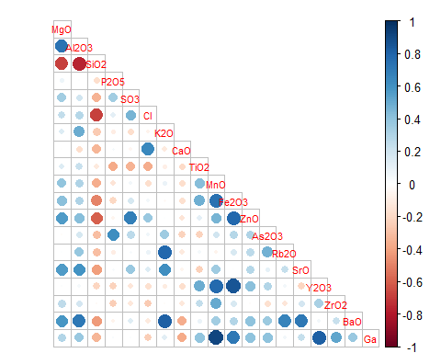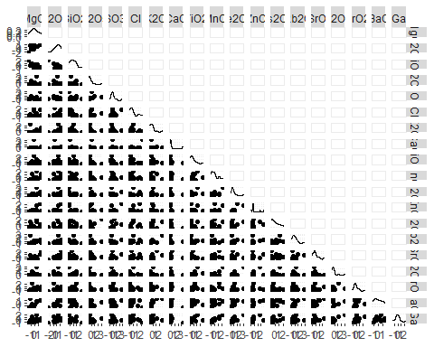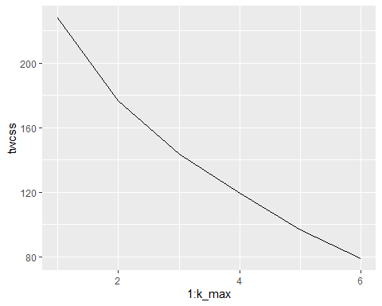

## Importance of components:  
## PC1 PC2 PC3 PC4 PC5 PC6 PC7  
## Standard deviation 2.4331 1.9011 1.6155 1.4016 1.24956 1.08327 0.94306  
## Proportion of Variance 0.3116 0.1902 0.1373 0.1034 0.08218 0.06176 0.04681  
## Cumulative Proportion 0.3116 0.5018 0.6392 0.7426 0.82473 0.88649 0.93330  
## PC8 PC9 PC10 PC11 PC12 PC13  
## Standard deviation 0.72080 0.59170 0.56800 0.2349 0.14099 3.143e-16  
## Proportion of Variance 0.02734 0.01843 0.01698 0.0029 0.00105 0.000e+00  
## Cumulative Proportion 0.96064 0.97907 0.99605 0.9990 1.00000 1.000e+00

## Importance of components:  
## PC1 PC2 PC3 PC4 PC5 PC6 PC7  
## Standard deviation 1.6229 1.3003 1.1248 0.8758 0.67152 0.36012 0.24983  
## Proportion of Variance 0.3763 0.2415 0.1807 0.1096 0.06442 0.01853 0.00892  
## Cumulative Proportion 0.3763 0.6178 0.7986 0.9081 0.97256 0.99108 1.00000

## Importance of components:  
## PC1 PC2 PC3 PC4 PC5 PC6 PC7  
## Standard deviation 2.1357 1.5133 1.2280 0.98751 0.93697 0.65470 0.44458  
## Proportion of Variance 0.4146 0.2082 0.1371 0.08865 0.07981 0.03897 0.01797  
## Cumulative Proportion 0.4146 0.6228 0.7599 0.84856 0.92837 0.96734 0.98530  
## PC8 PC9 PC10 PC11  
## Standard deviation 0.31665 0.21824 0.09870 0.06334  
## Proportion of Variance 0.00912 0.00433 0.00089 0.00036  
## Cumulative Proportion 0.99442 0.99875 0.99964 1.00000

## Importance of components:  
## PC1 PC2 PC3 PC4 PC5 PC6 PC7  
## Standard deviation 2.1063 1.4618 1.1688 0.9701 0.7204 0.62941 0.33038  
## Proportion of Variance 0.4436 0.2137 0.1366 0.0941 0.0519 0.03962 0.01092  
## Cumulative Proportion 0.4436 0.6573 0.7939 0.8881 0.9399 0.97956 0.99048  
## PC8 PC9 PC10  
## Standard deviation 0.27702 0.12028 0.06338  
## Proportion of Variance 0.00767 0.00145 0.00040  
## Cumulative Proportion 0.99815 0.99960 1.00000

## Importance of components:  
## PC1 PC2 PC3 PC4 PC5 PC6 PC7  
## Standard deviation 1.686 1.5041 1.2262 1.0331 0.73399 0.64385 0.48814  
## Proportion of Variance 0.316 0.2514 0.1671 0.1186 0.05986 0.04606 0.02648  
## Cumulative Proportion 0.316 0.5674 0.7345 0.8530 0.91290 0.95896 0.98543  
## PC8 PC9  
## Standard deviation 0.35144 0.08703  
## Proportion of Variance 0.01372 0.00084  
## Cumulative Proportion 0.99916 1.00000

## Importance of components:  
## PC1 PC2 PC3 PC4 PC5 PC6 PC7  
## Standard deviation 2.1616 1.5180 1.2283 1.04074 0.97526 0.86736 0.65054  
## Proportion of Variance 0.3894 0.1920 0.1257 0.09026 0.07926 0.06269 0.03527  
## Cumulative Proportion 0.3894 0.5814 0.7071 0.79739 0.87665 0.93935 0.97461  
## PC8 PC9 PC10 PC11 PC12  
## Standard deviation 0.42009 0.29946 0.17104 0.09595 0.00494  
## Proportion of Variance 0.01471 0.00747 0.00244 0.00077 0.00000  
## Cumulative Proportion 0.98932 0.99679 0.99923 1.00000 1.00000

## Importance of components:  
## PC1 PC2 PC3 PC4 PC5 PC6 PC7  
## Standard deviation 1.9046 1.5645 1.1973 1.0552 0.95751 0.87128 0.66114  
## Proportion of Variance 0.3298 0.2225 0.1303 0.1012 0.08335 0.06901 0.03974  
## Cumulative Proportion 0.3298 0.5523 0.6826 0.7839 0.86720 0.93621 0.97595  
## PC8 PC9 PC10 PC11  
## Standard deviation 0.46140 0.19371 0.10781 0.05046  
## Proportion of Variance 0.01935 0.00341 0.00106 0.00023  
## Cumulative Proportion 0.99530 0.99871 0.99977 1.00000

## Importance of components:  
## PC1 PC2 PC3 PC4 PC5 PC6 PC7  
## Standard deviation 1.9014 1.3650 1.1634 1.0113 0.89207 0.86017 0.63626  
## Proportion of Variance 0.3615 0.1863 0.1353 0.1023 0.07958 0.07399 0.04048  
## Cumulative Proportion 0.3615 0.5478 0.6832 0.7855 0.86504 0.93903 0.97951  
## PC8 PC9 PC10  
## Standard deviation 0.41974 0.14026 0.09507  
## Proportion of Variance 0.01762 0.00197 0.00090  
## Cumulative Proportion 0.99713 0.99910 1.00000

## Importance of components:  
## PC1 PC2 PC3 PC4 PC5 PC6 PC7  
## Standard deviation 1.8727 1.6005 1.1840 1.1551 0.84125 0.80525 0.63582  
## Proportion of Variance 0.3188 0.2329 0.1275 0.1213 0.06434 0.05895 0.03675  
## Cumulative Proportion 0.3188 0.5517 0.6792 0.8004 0.86477 0.92372 0.96047  
## PC8 PC9 PC10 PC11  
## Standard deviation 0.48574 0.43123 0.11345 0.005484  
## Proportion of Variance 0.02145 0.01691 0.00117 0.000000  
## Cumulative Proportion 0.98192 0.99883 1.00000 1.000000

## Importance of components:  
## PC1 PC2 PC3 PC4 PC5 PC6 PC7  
## Standard deviation 1.7472 1.3638 1.169 0.87510 0.74088 0.51244 0.32608  
## Proportion of Variance 0.3816 0.2325 0.171 0.09573 0.06861 0.03282 0.01329  
## Cumulative Proportion 0.3816 0.6141 0.785 0.88076 0.94937 0.98220 0.99549  
## PC8  
## Standard deviation 0.19001  
## Proportion of Variance 0.00451  
## Cumulative Proportion 1.00000

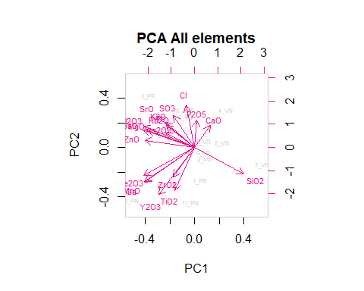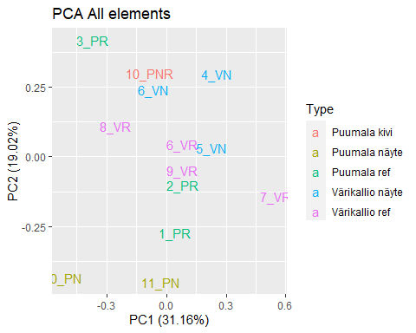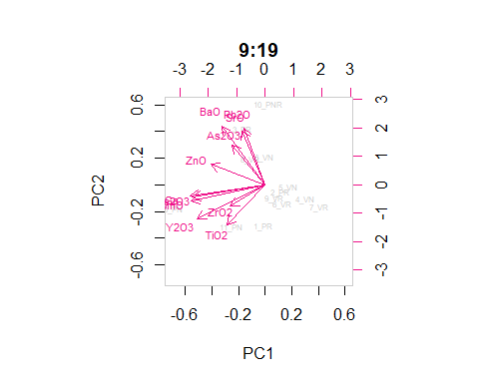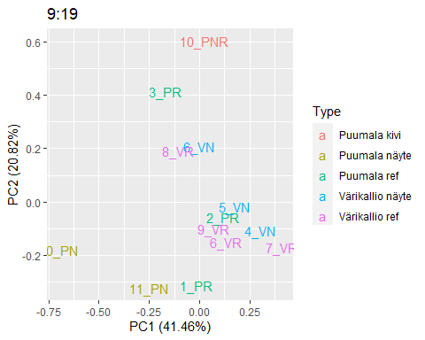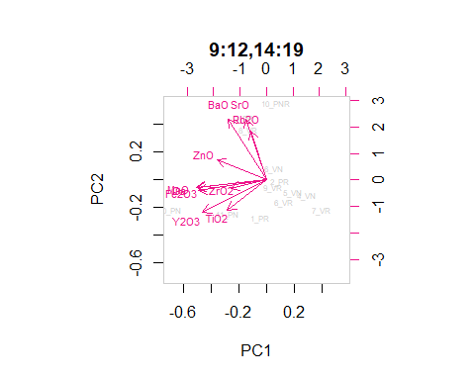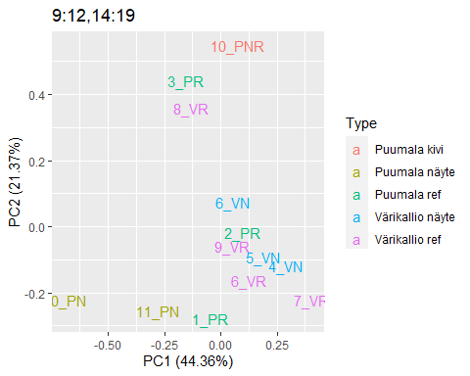

## [1] 0.4773373

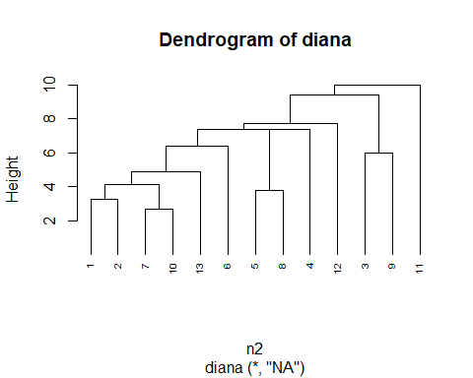

## [1] "1_PR" "2_PR" "3_PR" "10_PN" "10_PNR" "11_PN"

## Importance of components:  
## PC1 PC2 PC3 PC4 PC5 PC6  
## Standard deviation 2.744 2.6898 1.9243 1.4908 0.86997 3.619e-16  
## Proportion of Variance 0.351 0.3374 0.1727 0.1036 0.03529 0.000e+00  
## Cumulative Proportion 0.351 0.6884 0.8611 0.9647 1.00000 1.000e+00

## Importance of components:  
## PC1 PC2 PC3 PC4 PC5 PC6  
## Standard deviation 1.827 1.3247 0.68551 0.31733 0.05482 1.406e-17  
## Proportion of Variance 0.589 0.3097 0.08295 0.01777 0.00053 0.000e+00  
## Cumulative Proportion 0.589 0.8988 0.98169 0.99947 1.00000 1.000e+00

## Importance of components:  
## PC1 PC2 PC3 PC4 PC5 PC6  
## Standard deviation 2.6106 2.0813 1.3468 1.20646 0.55485 2.623e-16  
## Proportion of Variance 0.4628 0.2942 0.1232 0.09885 0.02091 0.000e+00  
## Cumulative Proportion 0.4628 0.7570 0.8802 0.97909 1.00000 1.000e+00

## Importance of components:  
## PC1 PC2 PC3 PC4 PC5 PC6  
## Standard deviation 2.6021 1.9379 1.3385 1.10192 0.55222 3.755e-16  
## Proportion of Variance 0.4893 0.2714 0.1295 0.08775 0.02204 0.000e+00  
## Cumulative Proportion 0.4893 0.7607 0.8902 0.97796 1.00000 1.000e+00

## Importance of components:  
## PC1 PC2 PC3 PC4 PC5 PC6  
## Standard deviation 2.3139 1.8883 1.4437 0.76395 0.54124 2.072e-16  
## Proportion of Variance 0.4507 0.3001 0.1754 0.04912 0.02466 0.000e+00  
## Cumulative Proportion 0.4507 0.7508 0.9262 0.97534 1.00000 1.000e+00

## Importance of components:  
## PC1 PC2 PC3 PC4 PC5 PC6  
## Standard deviation 2.6108 2.0814 1.3482 1.20703 0.5576 1.707e-16  
## Proportion of Variance 0.4626 0.2940 0.1234 0.09888 0.0211 0.000e+00  
## Cumulative Proportion 0.4626 0.7567 0.8800 0.97890 1.0000 1.000e+00

## Importance of components:  
## PC1 PC2 PC3 PC4 PC5 PC6  
## Standard deviation 2.4938 2.0893 1.3581 1.3149 0.49419 1.049e-16  
## Proportion of Variance 0.4318 0.3031 0.1281 0.1201 0.01696 0.000e+00  
## Cumulative Proportion 0.4318 0.7349 0.8630 0.9830 1.00000 1.000e+00

## Importance of components:  
## PC1 PC2 PC3 PC4 PC5 PC6  
## Standard deviation 2.3701 1.9690 1.3177 1.1609 0.49165 2.878e-16  
## Proportion of Variance 0.4382 0.3024 0.1354 0.1051 0.01885 0.000e+00  
## Cumulative Proportion 0.4382 0.7406 0.8760 0.9811 1.00000 1.000e+00

## Importance of components:  
## PC1 PC2 PC3 PC4 PC5 PC6  
## Standard deviation 2.1292 1.9001 1.2687 1.04276 0.7498 2.639e-16  
## Proportion of Variance 0.3976 0.3166 0.1412 0.09535 0.0493 0.000e+00  
## Cumulative Proportion 0.3976 0.7142 0.8553 0.95070 1.0000 1.000e+00

## Importance of components:  
## PC1 PC2 PC3 PC4 PC5 PC6  
## Standard deviation 2.0426 1.8502 1.1938 0.93102 0.39158 2.948e-16  
## Proportion of Variance 0.4155 0.3409 0.1419 0.08633 0.01527 0.000e+00  
## Cumulative Proportion 0.4155 0.7565 0.8984 0.98473 1.00000 1.000e+00

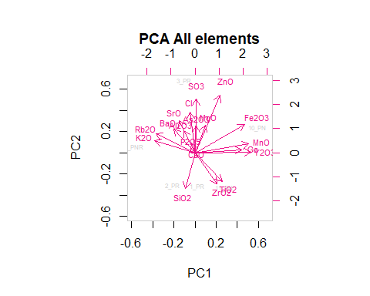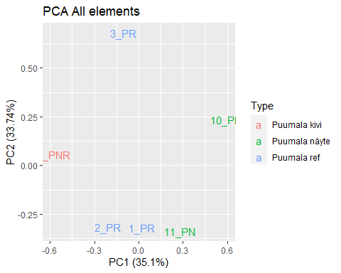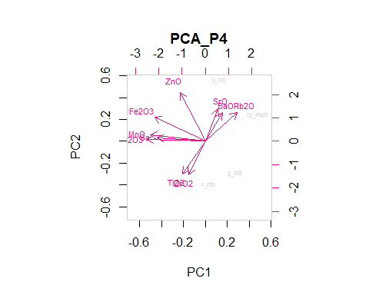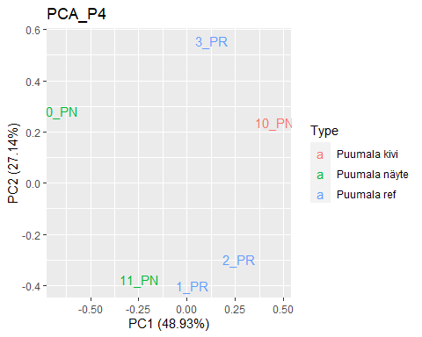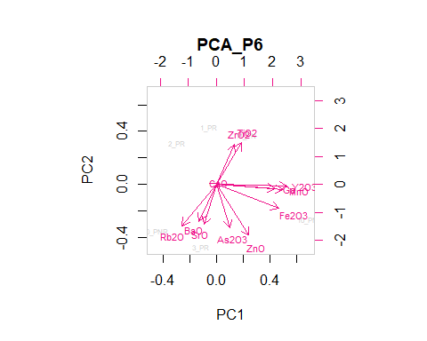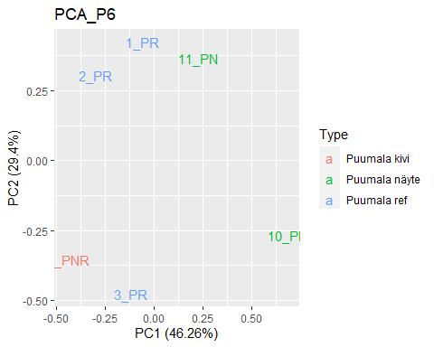

## [1] 0.2825678

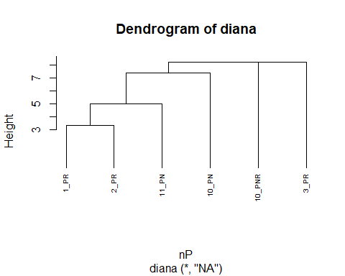

## [1] "4_VN" "5_VN" "6_VN" "6_VR" "7_VR" "8_VR" "9_VR"

## Importance of components:  
## PC1 PC2 PC3 PC4 PC5 PC6 PC7  
## Standard deviation 2.6242 1.9417 1.7480 0.95472 0.50565 0.38668 3.351e-16  
## Proportion of Variance 0.4582 0.2509 0.2033 0.06065 0.01701 0.00995 0.000e+00  
## Cumulative Proportion 0.4582 0.7091 0.9124 0.97304 0.99005 1.00000 1.000e+00

## Importance of components:  
## PC1 PC2 PC3 PC4 PC5 PC6 PC7  
## Standard deviation 1.9240 1.5458 1.2391 0.67954 0.37399 0.13093 7.52e-17  
## Proportion of Variance 0.4489 0.2898 0.1862 0.05601 0.01696 0.00208 0.00e+00  
## Cumulative Proportion 0.4489 0.7387 0.9250 0.98096 0.99792 1.00000 1.00e+00

## Importance of components:  
## PC1 PC2 PC3 PC4 PC5 PC6 PC7  
## Standard deviation 1.9285 1.2090 0.53229 0.34267 0.31611 0.10981 1.751e-16  
## Proportion of Variance 0.6532 0.2567 0.04976 0.02062 0.01755 0.00212 0.000e+00  
## Cumulative Proportion 0.6532 0.9099 0.95971 0.98033 0.99788 1.00000 1.000e+00

## Importance of components:  
## PC1 PC2 PC3 PC4 PC5 PC6 PC7  
## Standard deviation 1.9280 0.63048 0.37824 0.32919 0.29771 0.10160 1.278e-16  
## Proportion of Variance 0.8325 0.08903 0.03204 0.02427 0.01985 0.00231 0.000e+00  
## Cumulative Proportion 0.8325 0.92152 0.95357 0.97784 0.99769 1.00000 1.000e+00

## Importance of components:  
## PC1 PC2 PC3 PC4 PC5 PC6 PC7  
## Standard deviation 1.7089 1.1719 1.0046 0.54311 0.43317 0.15848 9.831e-17  
## Proportion of Variance 0.5026 0.2364 0.1737 0.05076 0.03229 0.00432 0.000e+00  
## Cumulative Proportion 0.5026 0.7389 0.9126 0.96339 0.99568 1.00000 1.000e+00

## Importance of components:  
## PC1 PC2 PC3 PC4 PC5 PC6 PC7  
## Standard deviation 1.9783 1.4281 1.0693 0.51618 0.3238 0.13491 1.179e-16  
## Proportion of Variance 0.5228 0.2725 0.1527 0.03559 0.0140 0.00243 0.000e+00  
## Cumulative Proportion 0.5228 0.7952 0.9480 0.98356 0.9976 1.00000 1.000e+00

## Importance of components:  
## PC1 PC2 PC3 PC4 PC5 PC6 PC7  
## Standard deviation 1.7046 1.4116 1.0498 0.42365 0.30255 0.14542 1.222e-16  
## Proportion of Variance 0.4618 0.3167 0.1752 0.02852 0.01455 0.00336 0.000e+00  
## Cumulative Proportion 0.4618 0.7784 0.9536 0.98209 0.99664 1.00000 1.000e+00

## Importance of components:  
## PC1 PC2 PC3 PC4 PC5 PC6 PC7  
## Standard deviation 1.5712 1.4056 1.0388 0.38582 0.29978 0.10071 1.196e-16  
## Proportion of Variance 0.4277 0.3422 0.1870 0.02579 0.01557 0.00176 0.000e+00  
## Cumulative Proportion 0.4277 0.7699 0.9569 0.98267 0.99824 1.00000 1.000e+00

## Importance of components:  
## PC1 PC2 PC3 PC4 PC5 PC6 PC7  
## Standard deviation 2.1018 1.7491 1.3046 0.80423 0.39461 0.20685 1.515e-16  
## Proportion of Variance 0.4407 0.3052 0.1698 0.06452 0.01553 0.00427 0.000e+00  
## Cumulative Proportion 0.4407 0.7459 0.9157 0.98020 0.99573 1.00000 1.000e+00

## Importance of components:  
## PC1 PC2 PC3 PC4 PC5 PC6 PC7  
## Standard deviation 1.7637 1.1975 0.51295 0.33001 0.2785 0.1025 1.586e-16  
## Proportion of Variance 0.6216 0.2865 0.05257 0.02176 0.0155 0.0021 0.000e+00  
## Cumulative Proportion 0.6216 0.9081 0.96064 0.98240 0.9979 1.0000 1.000e+00

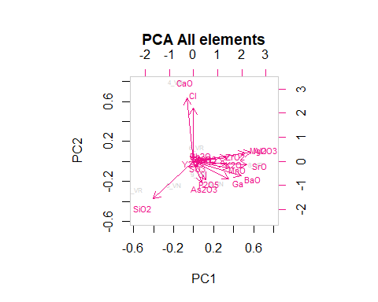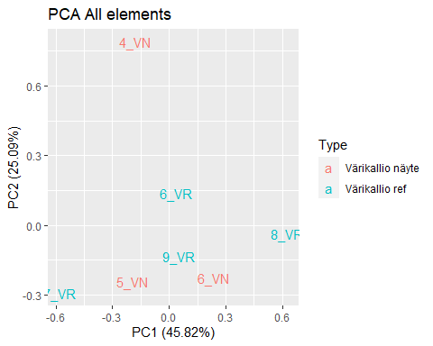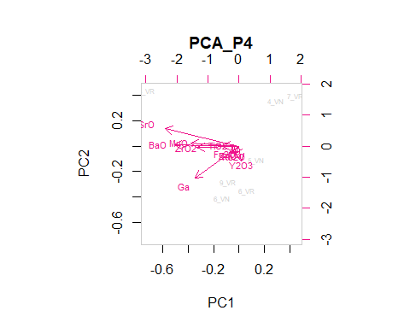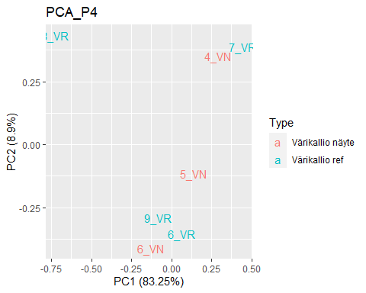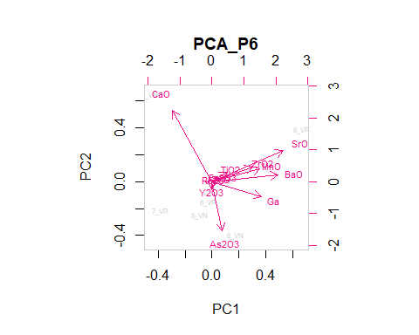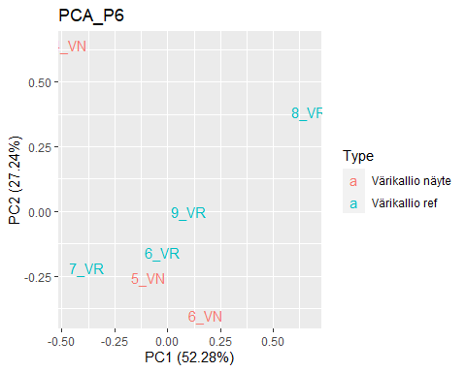

## [1] 0.3754779

